**STEP# 1**

Home PAGE: for the homepage. We will follow the same procedure of design. To see the design, click on this link below:

Link : <https://www.websitetechnic.com/>

Screenshot

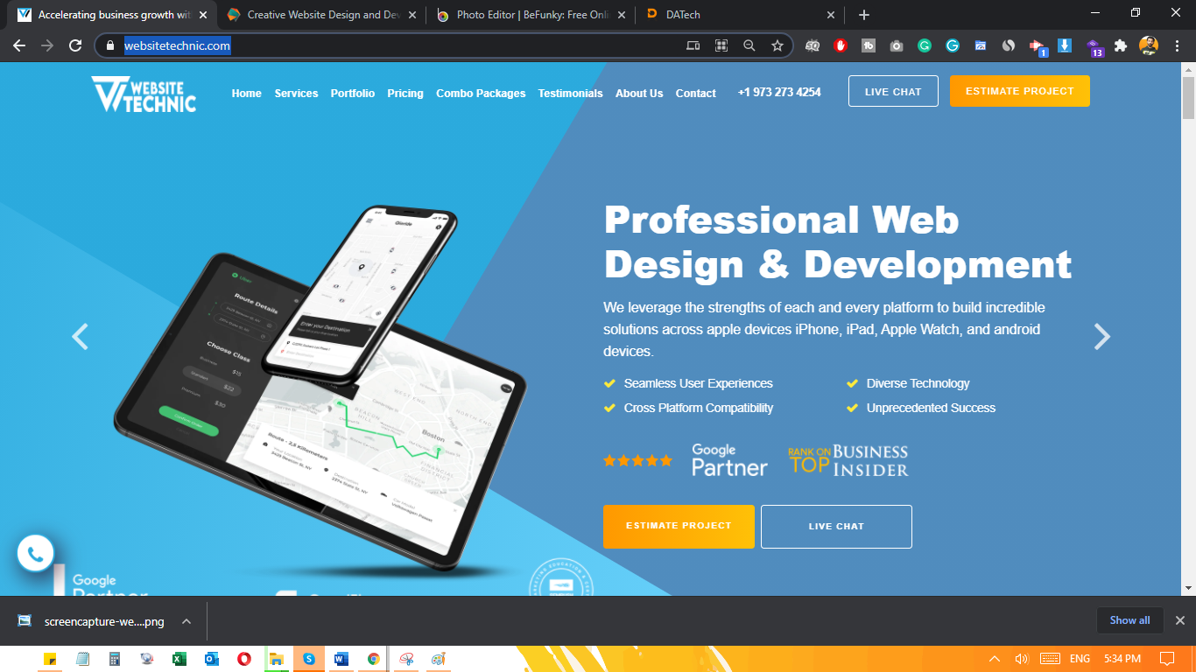

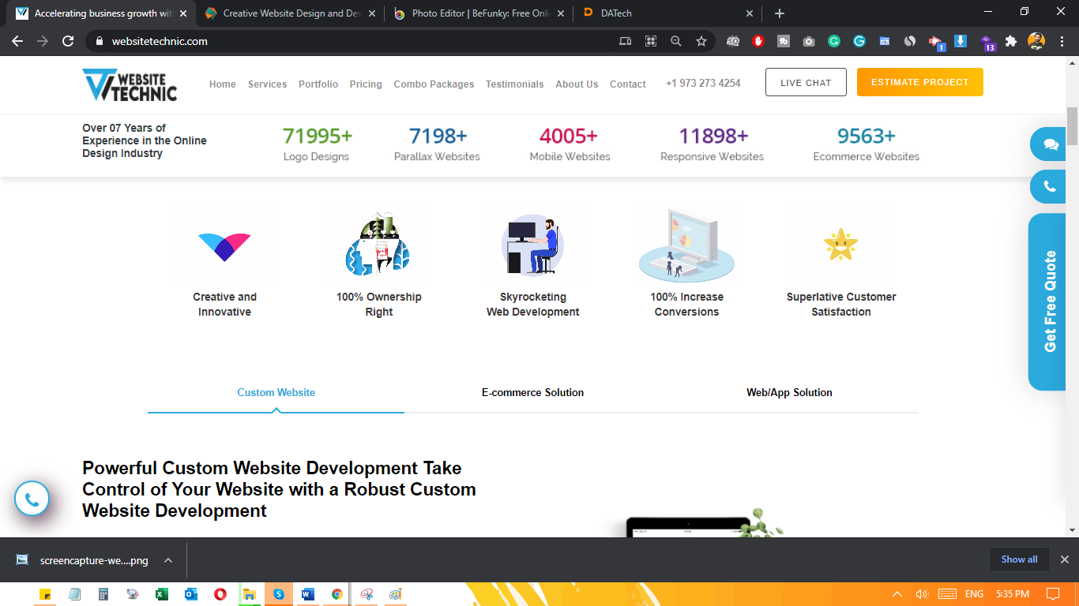

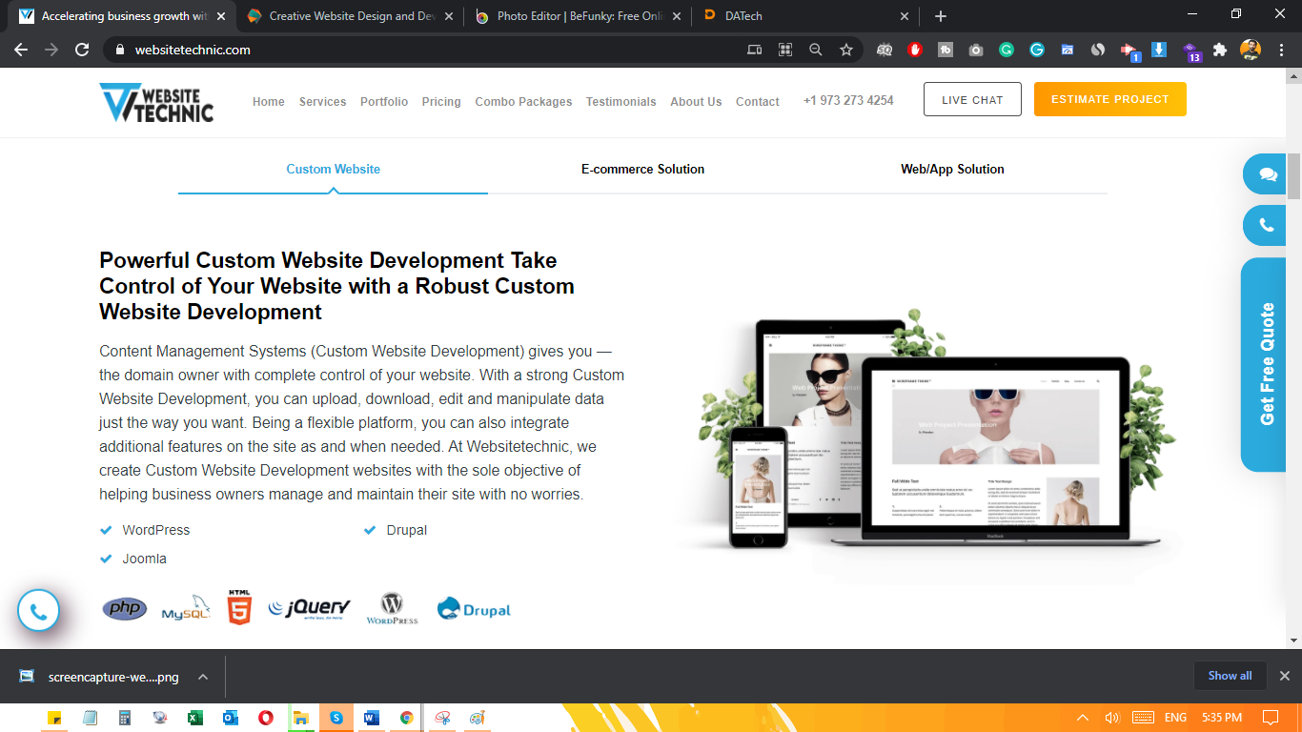

**STEP# 2**

When you reach the second section. Then you can follow the same procedure from second section which Is in <https://www.perfecent.com/> here is the picture below from where you can follow the procedure.

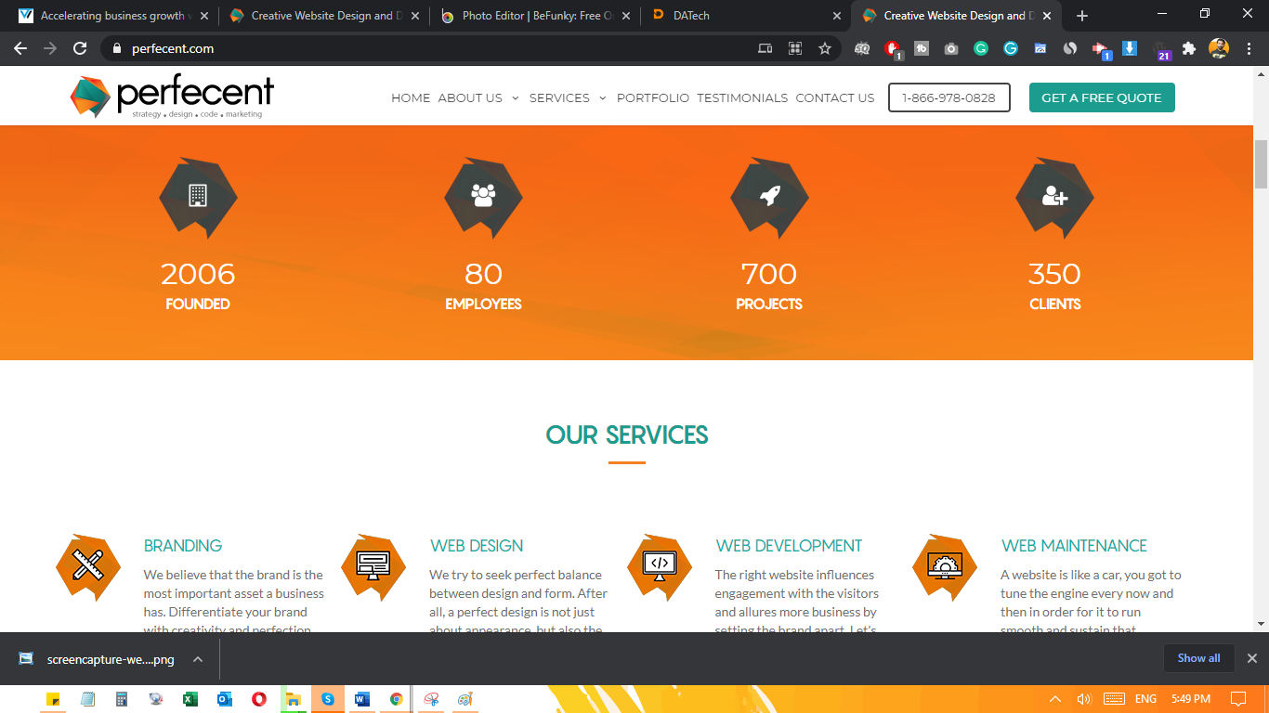

**Step# 3**

**Inner Pages (Services)**

We will follow the same category of “Services” Page and “Video animations” section will be removed

Screenshot: 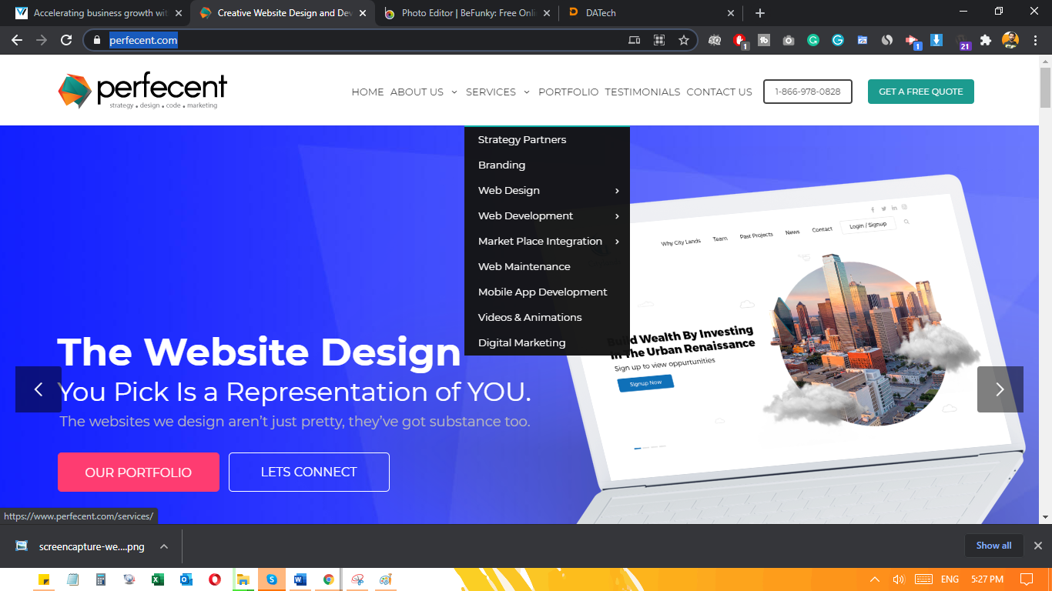

You can remove this section. Picture is below, and replaced with Testimonials

